**Practical No 8**

**Title:** Program for Two Dimensional Transformations (Rotation).

**Roll no:**   **Batch:**   **Class:** SYCM-

#include<stdio.h>

#include<graphics.h>

#include<conio.h>

#include<math.h>

void main()

{

int gd=DETECT,gm;

float x1,x2,x3,y1,y2,y3,nx1,nx2,nx3,ny1,ny2,ny3,r,t;

initgraph(&gd,&gm,"C:\\TC\\BGI");

printf("ROTATION");

printf("\nEnter Coordinates of Triangle: ");

scanf("%f %f %f %f %f %f",&x1,&y1,&x2,&y2,&x3,&y3);

setcolor(2);

line(x1,y1,x2,y2);

line(x2,y2,x3,y3);

line(x3,y3,x1,y1);

printf("\n Enter Rotation Angle: ");

scanf("%f", &r);

t=(r*3.14)/180;

nx1=abs(x1*cos(t)-y1*sin(t));

ny1=abs(x1*sin(t)+y1*cos(t));

nx2=abs(x2*cos(t)-y2*sin(t));

ny2=abs(x2*sin(t)+y2*cos(t)); **Output:-**

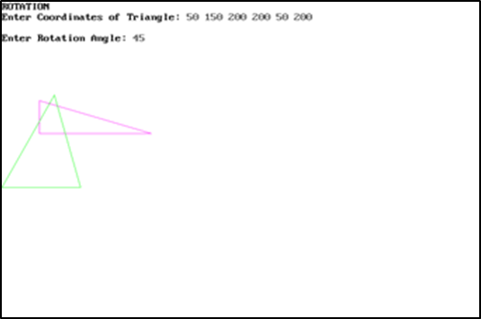nx3=abs(x3*cos(t)-y3*sin(t));

ny3=abs(y3*sin(t)+y3*cos(t));

setcolor(5);

line(nx1,ny1,nx2,ny2);

line(nx2,ny2,nx3,ny3);

line(nx3,ny3,nx1,ny1);

getch();

closegraph();

}